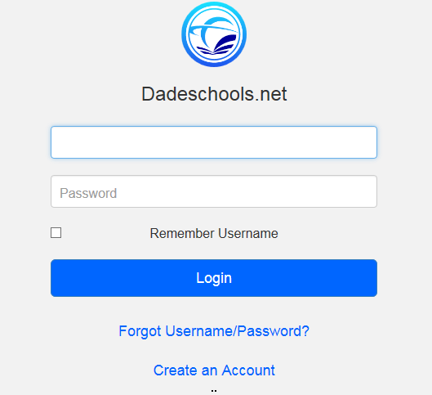
Accessing Your District Account

If you have never used your District account to access the portal
or District e-mail, you will have access using the following login
credentials:

• Username - Your Employee Number (Example: 123456)
• Password - Your First Name Initial (capitalized),
Last name initial (lower case) and birth date (mm/dd/yyyy):
example Mr01/01/1996

Instructions on how to change or reset your password can be found at: http://www2.dadeschools.net/passwordreset/passReset.asp?lang=en-us

Accessing the New Hire Enrollment Link
As a new employee you will receive an email notification 60 days after your date of hire prompting you to enroll online for your benefits. The email will provide you with your enrollment deadline.
HOW TO ENROLL:

- Log on to your employee portal through
dadeschools.net and click on the SAP icon
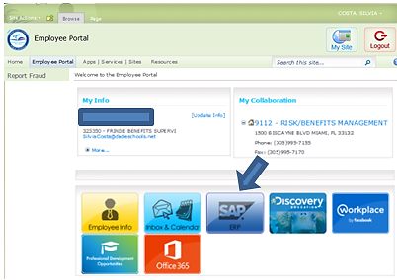

- Click on the Benefits link
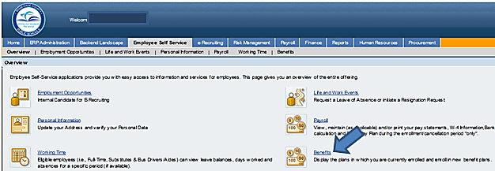

- Click on the Employee Self Service tab
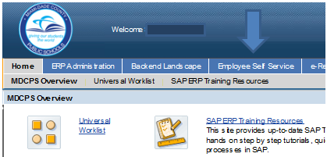

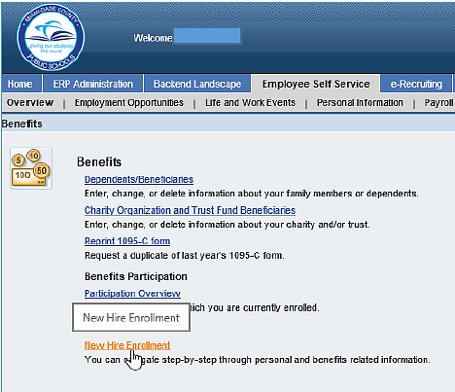
- Under Life Events, click on the New Hire Enrollment link

